PROJECT REPORT
Date | 27-FEB-2026
Team ID | LTVIP2026TMIDS79391
Project name | HematoVision: Advanced Blood Cell Classification Using Transfer Learning
Marks | 10 Marks

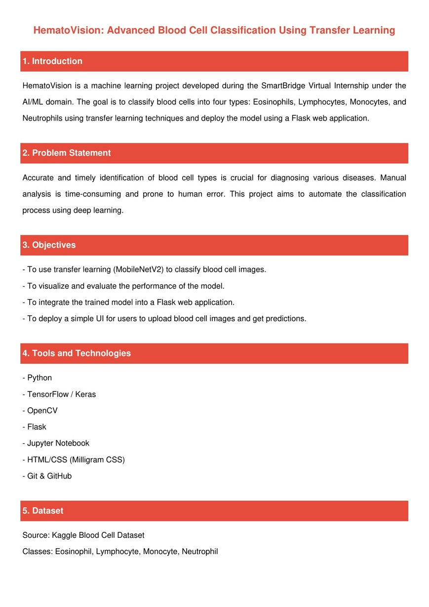

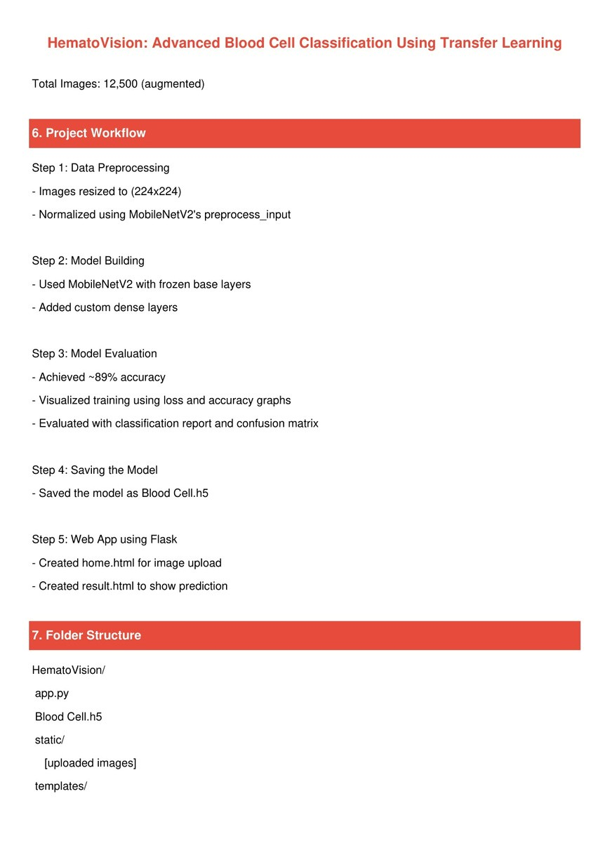
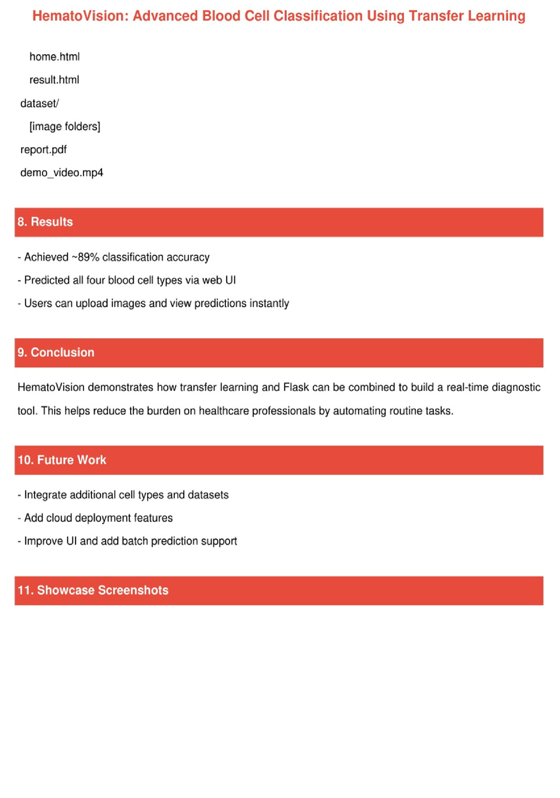

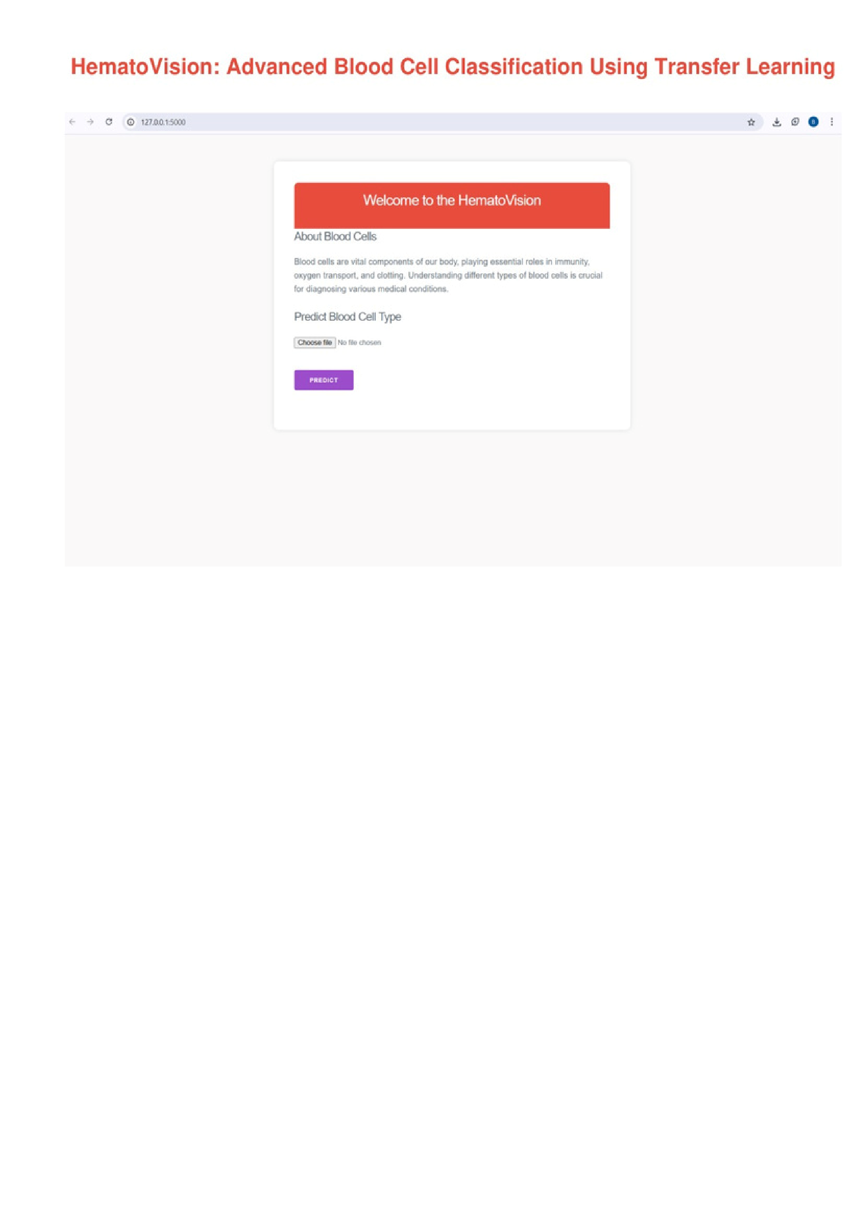
Allows the user to upload microscopic blood cell images (JPEG/PNG).
Ensures a user-friendly layout using Milligram CSS.
Prepares image for backend processing upon form submission.
Accepts files directly from local device storage.
Show Case ScreenShots:
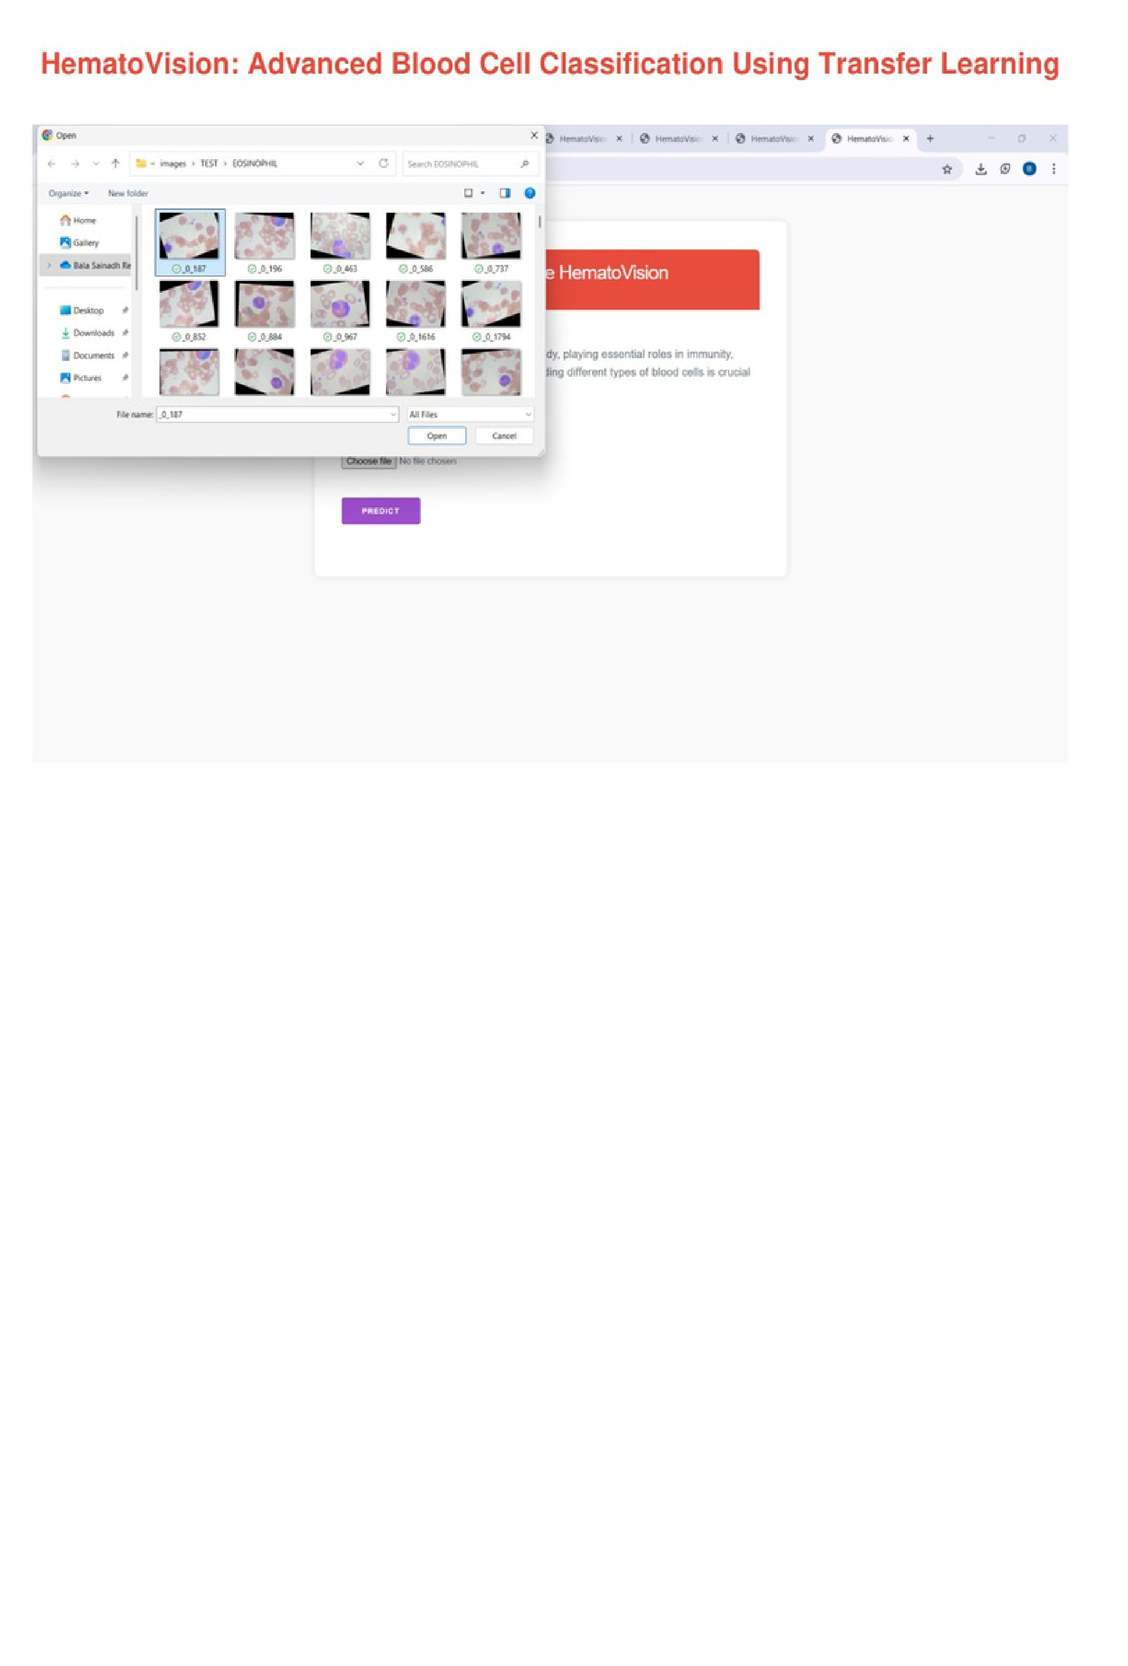
Triggered when the user clicks the Predict button.
The trained MobileNetV2 model processes and classifies the image.
Uploaded image is sent to Flask backend.
Prediction happens in real-time with fast response.
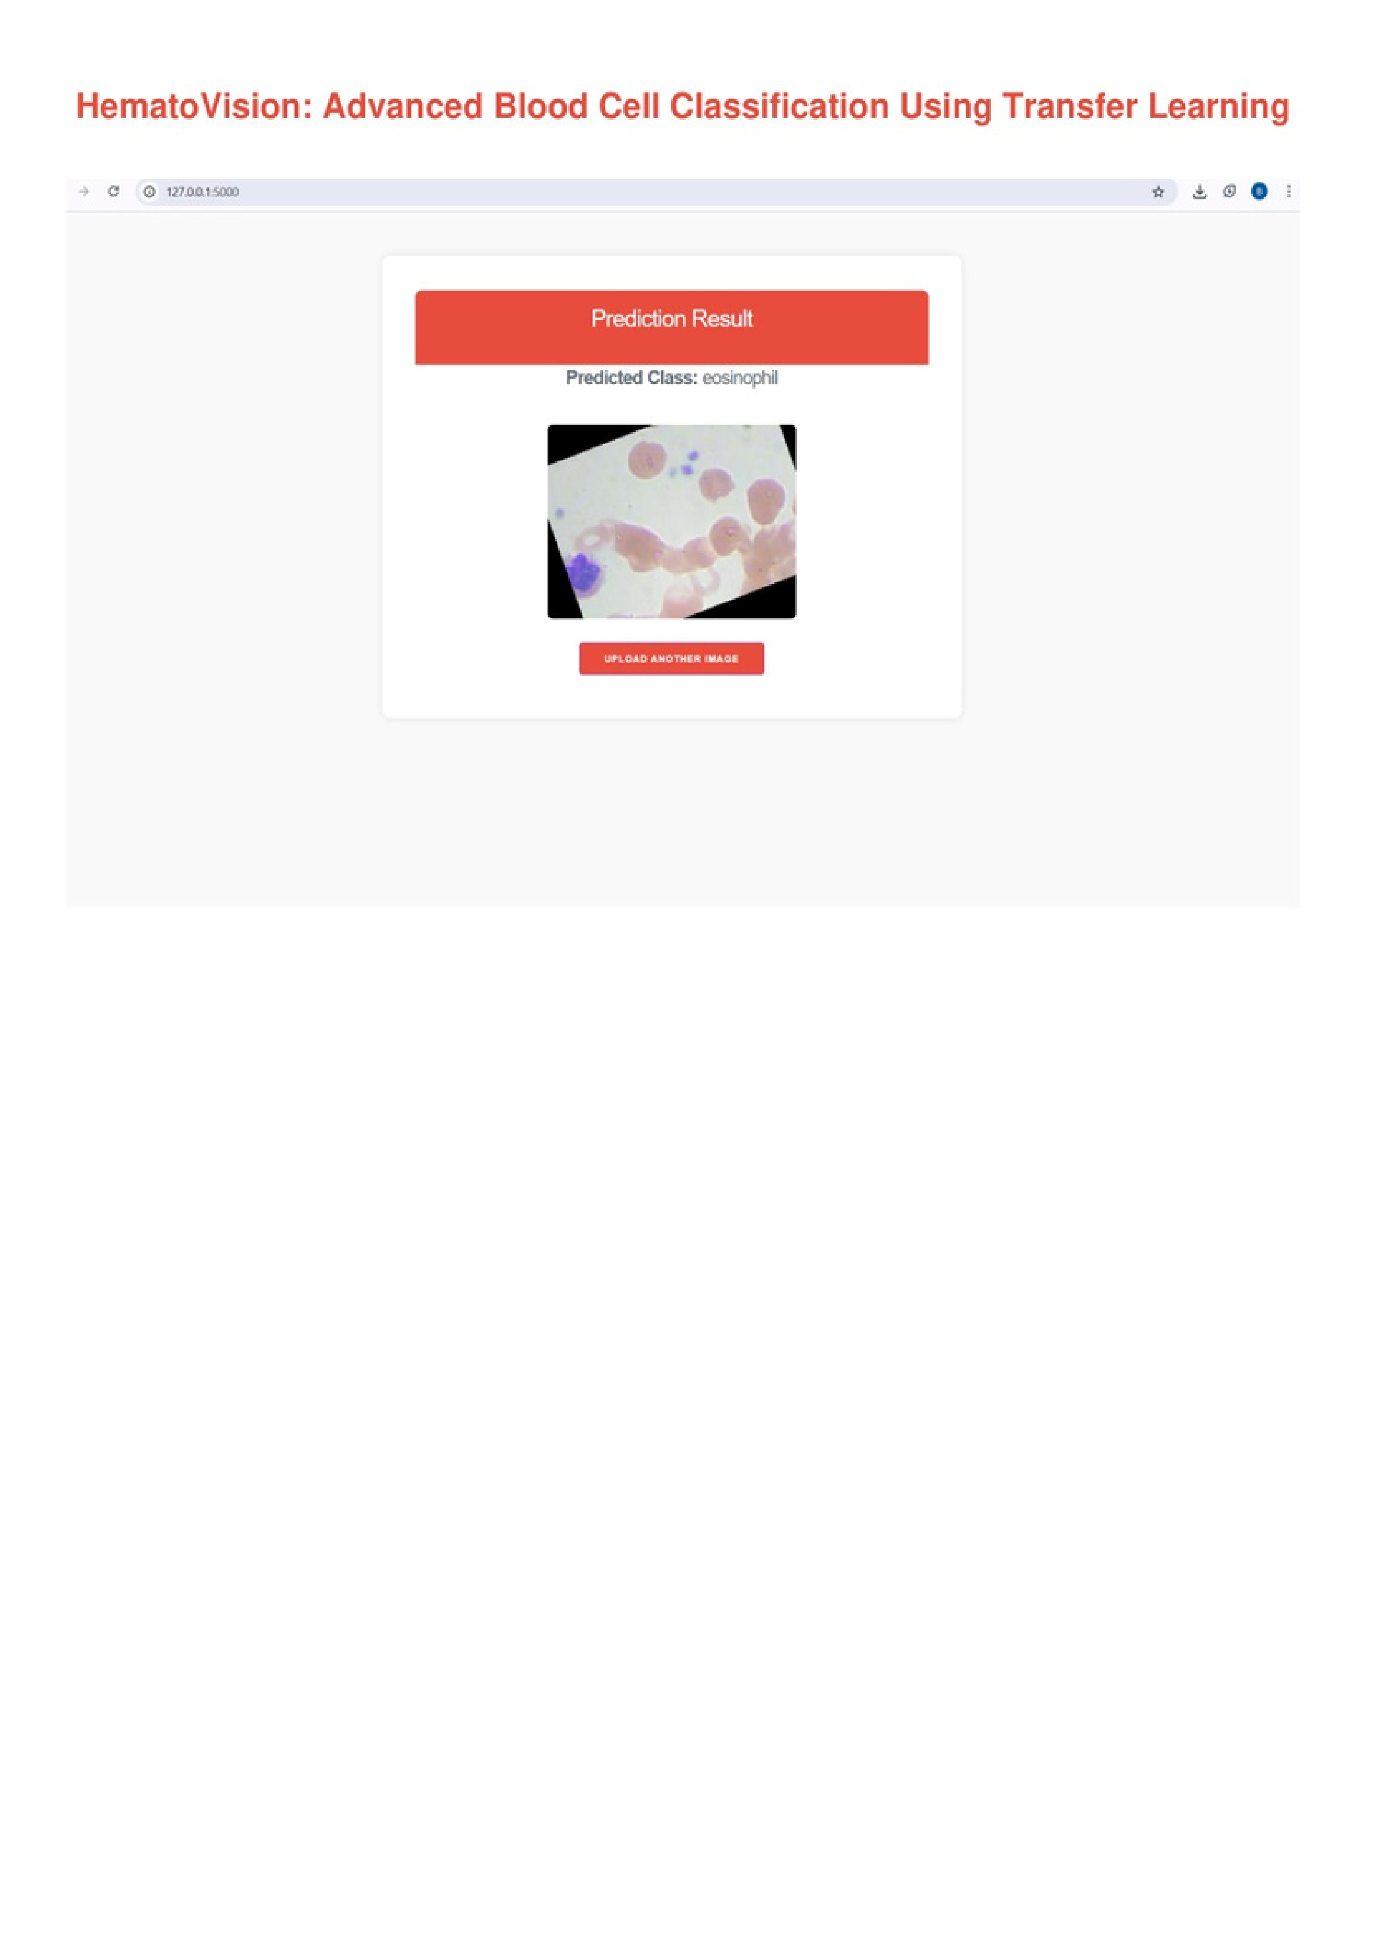
Displays the uploaded image preview alongside the predicted label.
Provides visual confirmation to the user.
Accurate result displayed using TensorFlow model's output.
Predicted blood cell type: Eosinophil, Lymphocyte, Monocyte, or Neutrophil.

